H.T No
Regulations:
A19

Sreenidhi Institute of Science and Technology
(An Autonomous Institution)
Code No: 7W102 Date: 31-Jan-2020 (FN)

M.Tech I-Year I-Semester External Examination, Jan/Feb-2020 (Regular)
ADVANCED FINITE ELEMENT ANALYSIS(CAD/CAM)

Time: 3 Hours Max.Marks:70

Note: a) No additional answer sheets will be provided.
b) All sub-parts of a question must be answered at one place only, otherwise it will not be valued.
c) Missing data can be assumed suitably.

Part - A Max.Marks:20

Answer all QUESTIONS.

1. | Differentiate between Finite Element Method and Finite Difference Method. | [2M]
2. | Write the formula of element stiffness matrix for frame element. | [2M]
3. | List out the assumptions made in beam theory. | [2M]
4. | Explain about the triangular membrane element using finite element model. | [2M]
5. | List the essential and natural boundary conditions in heat transfer analysis. | [2M]
6. | Discuss the assumptions made in analysis of incompressible fluid flow. | [2M]
7. | State the properties of Eigen vectors. | [2M]
8. | Define the assumptions made in bending of plates. | [2M]
9. | Enumerate the various factors in the selection of proper element type in finite element software. | [2M]
10. | Write the formula of consistent mass matrix and lumped mass matrix for a bar element. | [2M]
Part – B Max.Marks:50
ANSWER ANY FIVE QUESTIONS. EACH QUESTION CARRIES 10 MARKS.

11. |  | Perform the cholesky decomposition of the positive definite matrix.  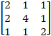 | [10M]
12. |  | Develop the element stiffness matrix for a frame element. | [10M]
13. |  | Derive the element stiffness matrix for triangular membrane element. | [10M]
14. |  | Determine the natural frequencies and mode shapes for the beam shown in figure. Take E= 200GPa, I = 2000mm⁴, ρ= 7840 kg/m³, A= 240mm².  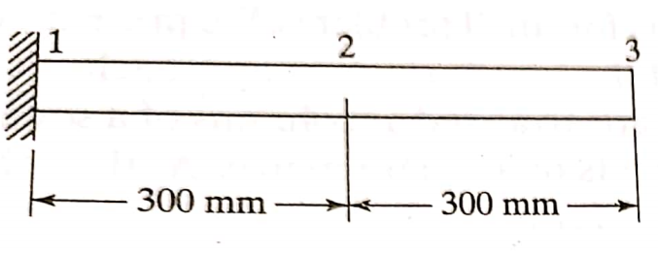 | [10M]
15. |  | A metallic fin, with thermal conductivity k= 360 W/m⁰C, 0.1cm thick and 10cm long extends from a plane wall whose temperature is 235⁰C. Determine the temperature distribution and amount of heat transferred from the fin to the air at 20⁰C with h= 9W/m² ⁰C. Take the width of the fin to be 1m. | [10M]
16. | a) | Discuss about various boundary conditions in the 1D flow problems. | [5M]
 | b) | Enumerate the various factors in the selection of proper element type in finite element software. | [5M]
17. | a) | Express the strain-displacement relation for plane stress condition. Represent them graphically. | [4M]
 | b) | Assumptions made in bending of rectangular plates. | [3M]
 | c) | Mention various boundary conditions for heat convection to take place. | [3M]

-- 00 -- 00 –

